**Language Processing**

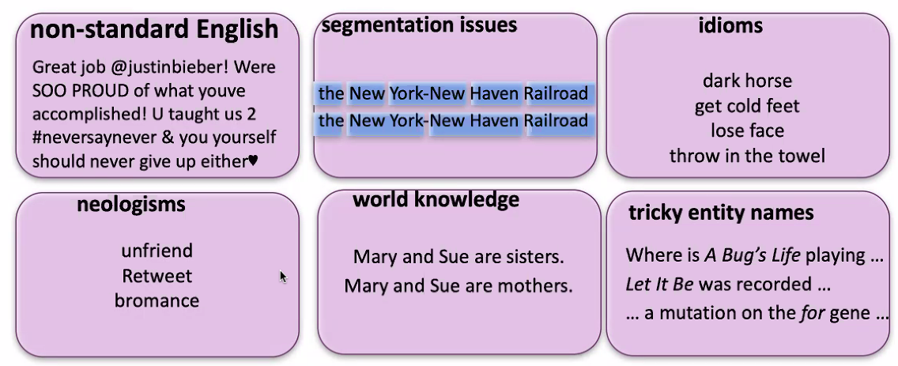

Google duplex

**Bag of words algorithm**

Just count word frequency, without considering positioning/context

-small words generally ignored (e.g. it, is)

Zipfs law: most frequent word occurs twice as often as next frequent word, which occurs twice as much as next frequent word.

-applies to nearly every human language, and even dolphins

-produces straight line on logarithmic plot

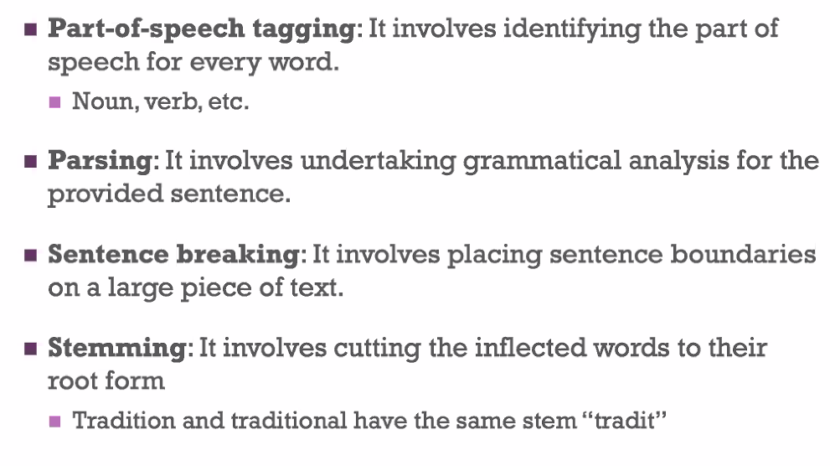

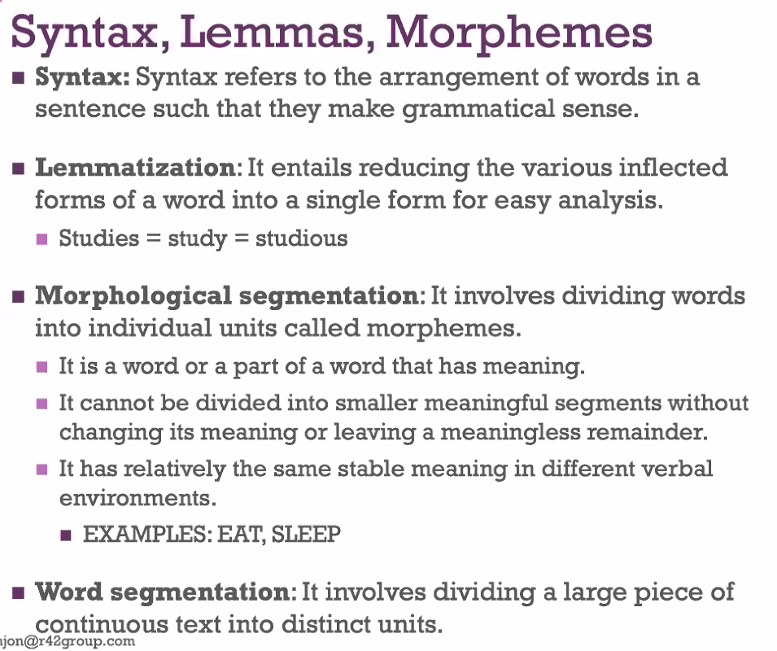

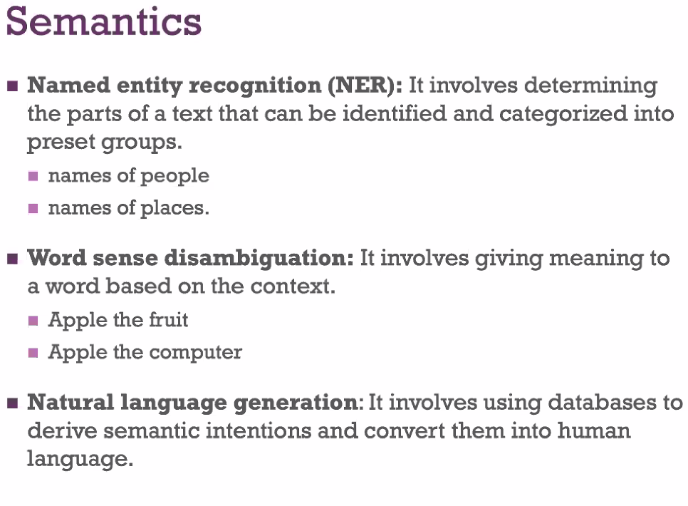

**Probabilistic models**

-assign probability to sentence

-used for spell correction/autocorrect

-uses chain rule of multiplying probabilities

-bayes theorem

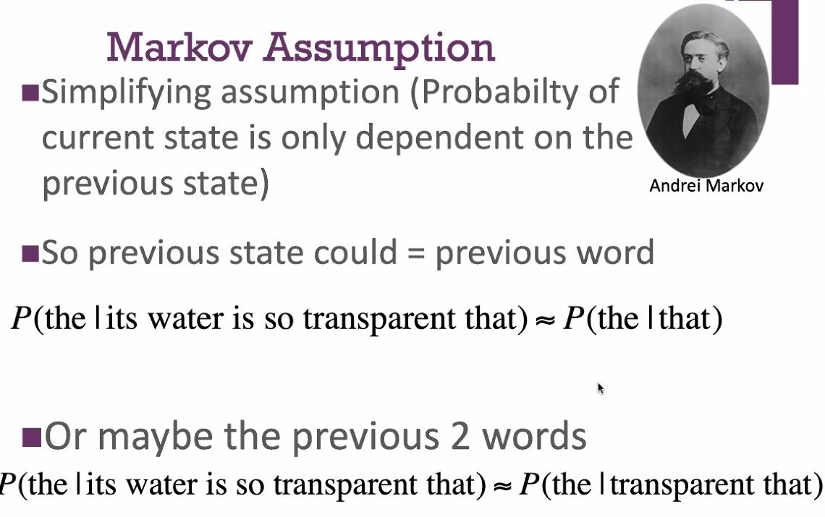

**Unigrams, bigrams (n-grams)**

Unigrams – probability of each individual word

Bigrams – probability of each consecutive pair of words in sentence

N-grams - do the above for n-number of consecutive words

Quadgrams needed to predict? Shakespeare

Semantic fields

-take into account related words

**Words as vectors**

Can say words are part of a vector and plot them by similarity, based on the environments they appear in

**LSTMs (Long short-term memory)**

Uses feedback connections

Type of recurrent neural network

-use previous layer/network outputs as inputs for later hidden layers?

-uses original inputs as inputs for later hidden layers?

**Transformer networks**

-not recurrent?

-uses idea of attention

-use previous outputs as inputs for later hidden layers?

-ore complex version of LSTM (

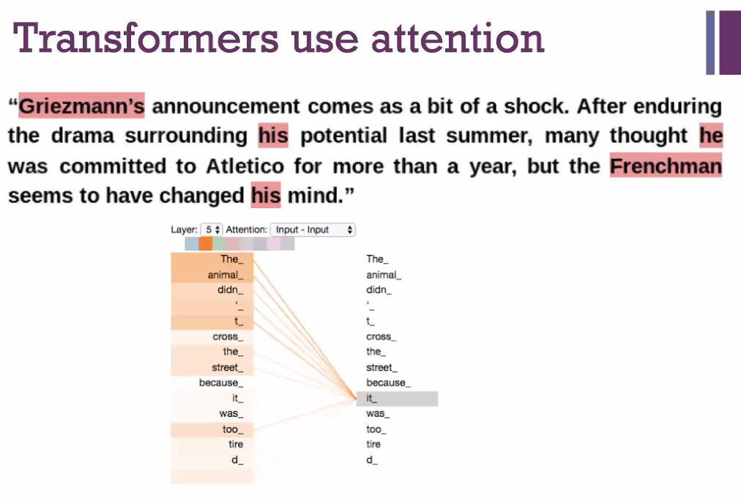

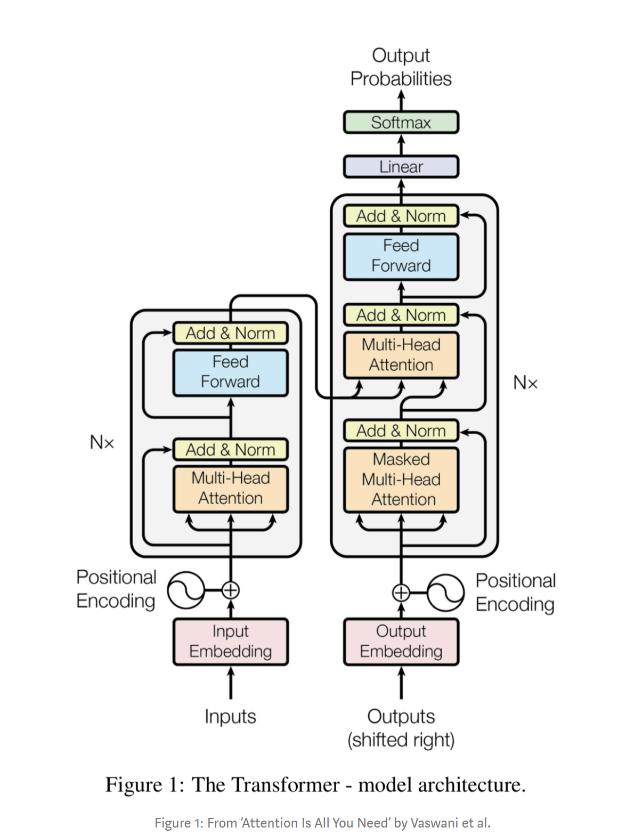

**Cognitive Architecture**

Architecture-arrangement/organisation of structural and functional elements to achieve some purpose

Soar is the leading cognitive architecture

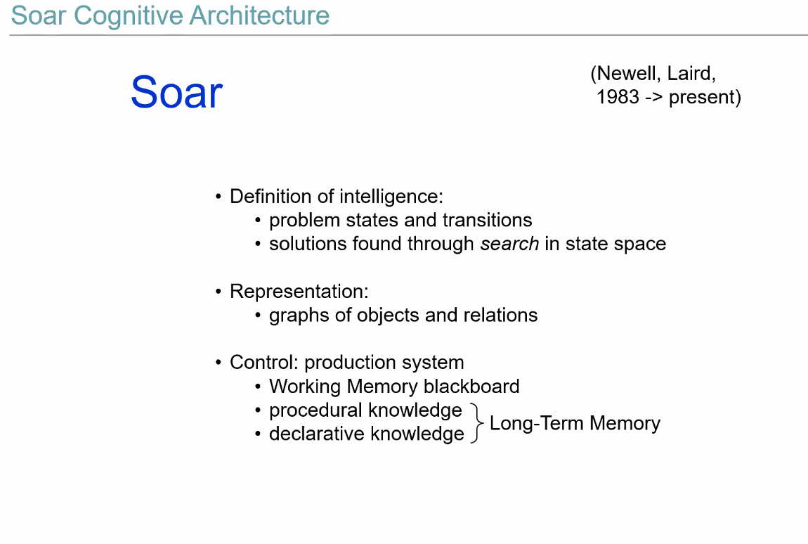

**Elements of Cognitive Behaviour Used**

Working memory

Semantic and episodic memory

Declarative and non-declarative/procedural long-term memory

Executive function-relevance of information, task shifting/interruptions, attention focusing, inhibiting distractors

**Marrs Three levels**

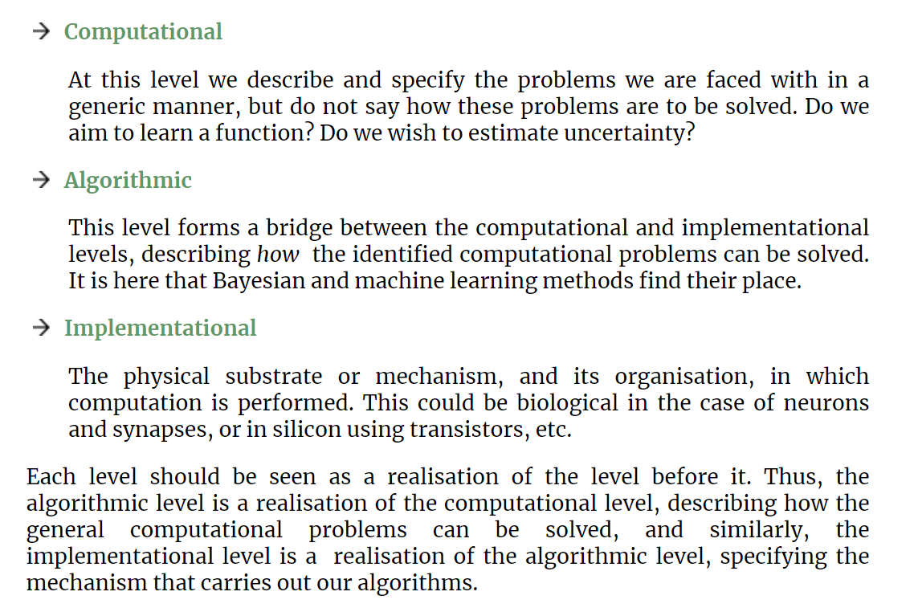

**Reactive Agent**

Perception-action loop is relatively automatic

Rules followed internally to process inputs and act based on them

**Deliberative Agent**

Includes long-term and working memory

Can engage in planning

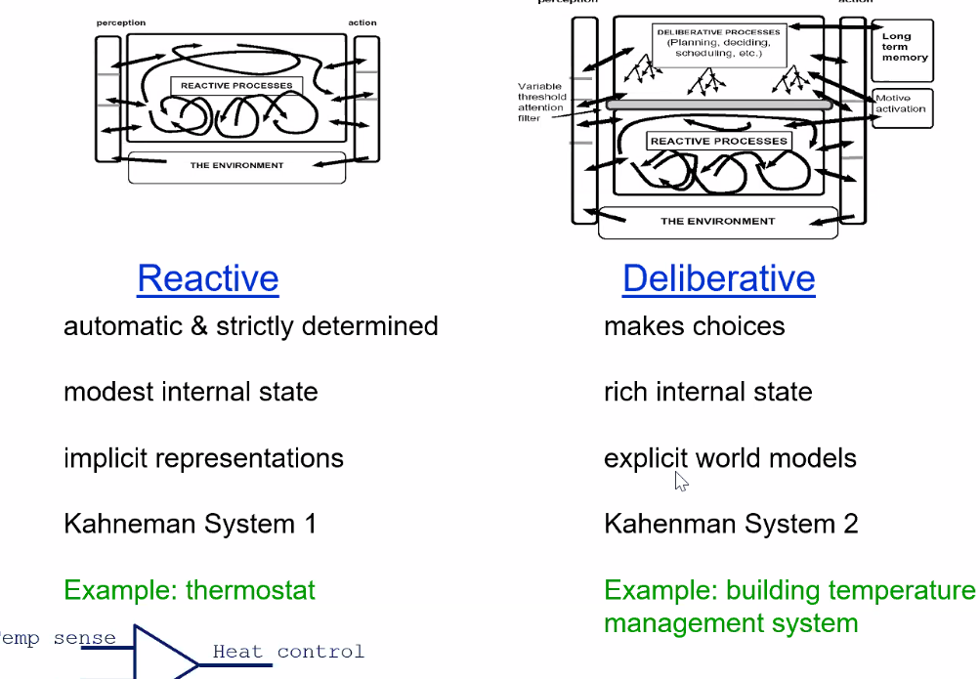

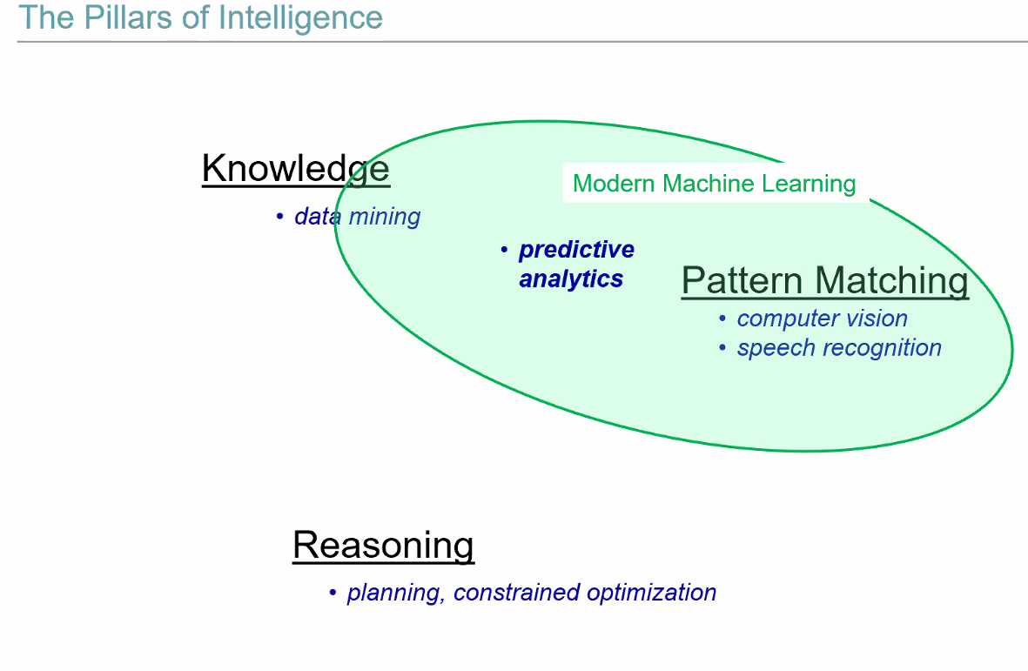

**Perception-action loop used in assistants like Alexa**

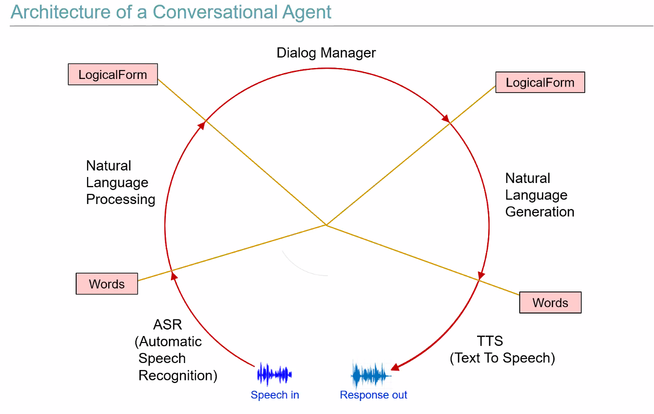

-mixed deliberative and reactive

-dialogue manager makes use of external knowledge resources

-can use pronoun resolution for basic follow-up question responses

**GPT3**

No executive function

No deliberative reasoning

Just interpolation?

**Confusion Matrix**

**Algorithmic bias**

Knowledge used

Reasoning process applied